# **Database Server Connection Guide**

Contents

**Database Server Connection Guide** 1

Create an account with Oracle 2

Install SQL Developer for Windows 2

Install SQL Developer for Mac 3

Run SQL Developer 3

Note for macOS 11.0 (also known as macOS Big Sur): 4

Create Connection to the Database Server 4

**Note to all:** 4

**Note to Trainers:** 4

Changing your password 5

## Create an account with Oracle

You will need to create an account and provide a valid email address on oracle.com to be able to download SQL Developer, but please **DO NOT USE FDM** **email** and use any other email address you have.

## Install SQL Developer for Windows

1. Download sqldeveloper-<latest_version>-x64.zip through:

<https://www.oracle.com/tools/downloads/sqldev-downloads.html>

1. Extract the sqldeveloper-<version>-x64.zip file to your preferred location.

For example F:\

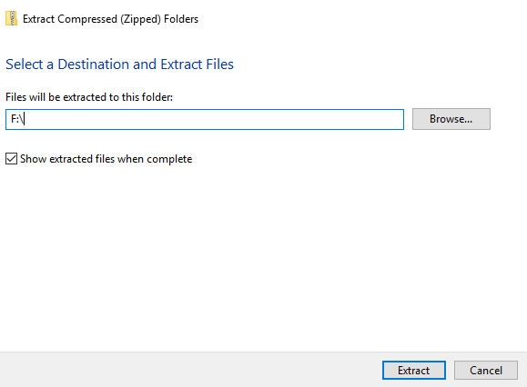

1. Create a shortcut on the Desktop and rename the shortcut to **SQL Developer**

F

## Install SQL Developer for Mac

1. Download sqldeveloper-<latest_version>-macosx.zip through the following and scrolling to Mac OSX:

<https://www.oracle.com/tools/downloads/sqldev-downloads.html>

1. Extract the sqldeveloper-19.2.1.247.2212-macosx.zip file to your preferred location.
2. Download jdk-11.0.9_osx-x64_bin.dmg file through:

<https://www.oracle.com/ca-en/java/technologies/javase-jdk11-downloads.html>

1. From either the browser Downloads window or from the file browser, double-click the .dmg file to start it.

A Finder window appears that contains an icon of an open box and the name of the .pkg file.

1. Double-click the JDK 11.pkg icon to start the installation application.

The installation application displays the Introduction window.

1. Click Continue.

The Installation Type window appears.

1. Click Install.

A window appears that displays the message: Installer is trying to install new software. Enter your password to allow this.

1. Enter the Administrator user name and password and click Install Software.

The software is installed and a confirmation window is displayed.

After the software is installed, you can delete the .dmg file if you want to save disk space.

## Run SQL Developer

1. Double click on SQL Developer

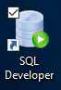

1. Choose No for importing preferences

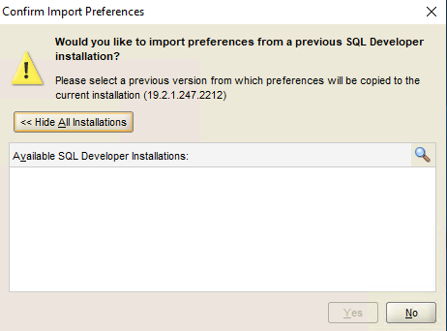

### Note for macOS 11.0 (also known as macOS Big Sur):

Launch SQL Developer from a Terminal session as follows:

1. Start a terminal window (e.g. by typing **terminal** in the spotlight)
2. Run **cd /Applications/SQLDeveloper.app/Contents/resources/sqldeveloper** (or the location where you extracted thesqldeveloper-19.2.1.247.2212-macosx.zip)
3. Run **zsh sqldeveloper.sh**

## Create Connection to the Database Server

1. Create Database Connection by clicking on the green + (Left up corner under connections) 
2. Fill the following information → Test → Save → Connect

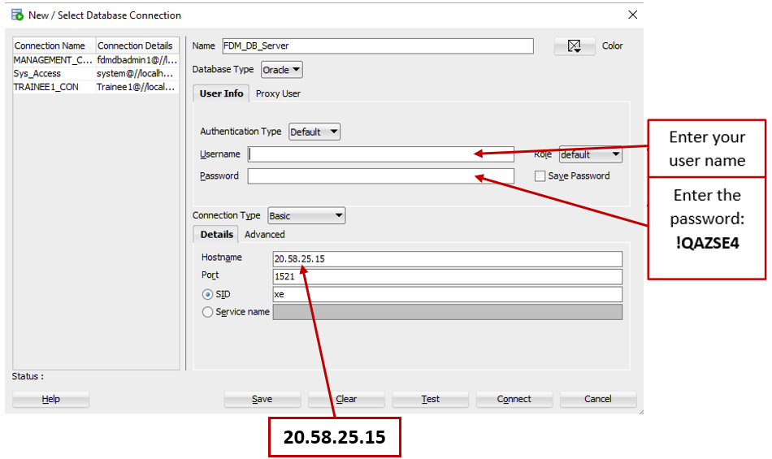

**Note to all:** Your user name is your first name followed by your last name without any space.

**Example:** the user name of **John Smith** is **johnsmith**

**Note to Trainers:** If GlobalProtect is ON or you are connecting from FDM Centers please use the following for the Hostname: **10.50.3.12**

## Changing your password

You can change the password for your accounts by connecting and using the following SQL statements:

ALTER SESSION SET "_ORACLE_SCRIPT"=true;

ALTER USER ***username*** IDENTIFIED BY "***newpassword***";

Please note the use of quotes and that the statements must be run in that particular order.